Tab 1
Real-Time Conflict Escalation Detection
Using GDELT Streaming Data for Humanitarian Early Warning
_____________________________________________________________________

Cameron Bendalin, Gabriela Garcia Gonzalez, Fidelis Ambrose Mahila Lnu,
Emily Tellschow, Rebecca Yoder

Unstructured & Distributed Data | Group 7 | Spring 2026

Abstract
News data on global conflicts are generated at an extraordinary speed and volume, yet humanitarian organizations responsible for deploying aid are often delayed by retrospective reporting that lags days behind the tactical reality on the ground. Every 15 minutes, the GDELT Project publishes a new snapshot of the global news cycle – millions of event records drawn from broadcast, print, and online sources in over 100 languages. The central challenge this project addresses is not whether GDELT contains useful conflict intelligence, but whether that intelligence can be reliably extracted in real time and translated into actionable insights for organizations operating within compressed decision windows.
This report presents the motivation, findings, and implications of a real-time conflict escalation detection system built on a serverless AWS architecture. By applying a structured transformation and classification pipeline to GDELT’s continuous data stream, the system isolates high-intensity signals from categorical noise, providing a country-level view of conflict intensity that updates with the news cycle rather than periodically. The resulting analytical interface offers stakeholders a range of visualizations that differentiate between media volume and operational distress, providing essential context for resource prioritization. Finally, we outline a roadmap for enhancing the system’s predictive utility through the integration of CAMEO event-code sequences and actor-specific granularity to provide deeper contextual detail for anticipatory action.

Background and Motivation
Humanitarian Organizations must make rapid decisions about where to dispatch personnel, supplies and financial resources. These decisions depend on accurate, current situational awareness. In practice, most organizations rely on manually prepared – written, reviewed and approved – situation reports that are published on cycles of days or weeks. By the time a situation report is presented, the situation on the ground may have escalated, de-escalated, or shifted geographically.
The internet produces a continuous torrent of news reporting the same event in near real time. Social media, wire services and broadcast transcripts, and online publications cover the conflicts as they unfold. This information is largely underutilized by stakeholders who lack tools to aggregate, filter and interpret it at scale.

Core Challenges
The primary challenge in modern crisis monitoring is the reconciliation of information velocity with signal reliability. While global crises evolve at a pace that renders traditional, authored reports obsolete, the transition to automated monitoring introduces significant complexities regarding data integrity. Specifically, the dissemination of news from conflict zones is often characterized by a high degree of categorical noise where the emotional intensity of reporting can obscure the actual operational impact of an event. Extracting a clean signal from this environment requires a level of computational processing that humans simply cannot perform at scale.
Furthermore, achieving comprehensive global coverage is complicated by the uneven density of the digital media landscape. Traditional monitoring frameworks tend to gravitate toward established geopolitical hot spots, creating a reporting bias that leaves under-represented regions vulnerable to strategic oversight. This disparity necessitates a system capable of normalizing data across diverse linguistic and geographic sources to ensure that emerging distress is not overshadowed by the sheer volume of output from media-rich environments.
Finally, the maintenance of consistent signal quality remains a persistent technical hurdle. The large volume of unstructured data available via the internet provides a vast quantity of information, but without a systematic framework for sentiment-derived classification, this data remains an undifferentiated mass. The central challenge addressed by this project is the construction of a streaming pipeline capable of transforming this chaotic data stream into a structured, country-level view of conflict intensity. The goal is to provide an efficient leading indicator that directs analytical attention toward intensifying distress without the system itself becoming a source of additional noise.

Dataset

The GDELT Project
The dataset powering this project is the Global Database of Events, Language, and Tone (GDELT). This is a free, open-access real-time data platform that monitors the world’s news media across broadcast, print and web services in more than 100 languages. GDELT records structured information every 15 minutes, 24 hours a day. There is a historical archive that stretches back to 1979, providing the opportunity for record validation and back testing.
Each record from GDELT represents a single news-reported interaction between two actors (countries, individuals or organizations). Events are coded using the CAMEO (Conflict and Mediation Event Observations) framework. CAMEO is a standardized international taxonomy that assigns numeric codes to hundreds of event types. This structure makes GDELT highly amenable to automate analysis.

Key Variables
Field | Type | Description
EventCode | Categorical | CAMEO event type
AvgTone | Numeric | Average sentiment tone of all news articles covering the event.
GoldsteinScale | Numeric | Theoretical stability impact of the event from -10 to +10 independent of media tone
ActionGeo_CountryCode | Categorical | ISO country code of the location where the event occurred
Mentions | Integer | Number of distinct news sources covering the event.
Table 1: Sentiment-Based Thresholds for Distress Signal Classification.
The Average Tone and Goldstein Scale provide the core of our analytical framework. While Average Tone captures the real-time international concern surrounding an event, the Goldstein Scale serves as a baseline for the event's physical severity based on the CAMEO taxonomy. By analyzing the delta between these two scores, the system can distinguish between media-driven distress and ground-truth escalation.

Geographic Scope
Country selection is based on standard ISO country codes and can be adjusted as priorities change.This filtering is applied during data ingestion, where the streaming layer selects events from the countries of interest.

Distress Classification
At the core of the system is a simple classification step that translates incoming news events into three levels of distress. The thresholds used for these categories are based on observed patterns in the data. Additionally, to ensure reliability, the pipeline was designed to handle incomplete or inconsistent data. Instead of failing when it encounters problematic records, it continues processing and maintains a steady flow of insights.

AvgTone Range | Classification | Interpretation
Above −1 | STABLE | Neutral or positive tone; no immediate concern
−3 to −1 | MONITORED EVENT | Elevated tension; situation requires tracking
Below −3 | CRITICAL | Severe negative tone; likely active conflict or escalating crisis
Table 2: Applied Weights of the Goldstein Scale for Structural Impact.

Methodology
The technical implementation of this system is built on a serverless, event-driven architecture hosted on Amazon Web Services (AWS), optimized for high-velocity data ingestion and transformation. The pipeline begins with a data acquisition layer powered by AWS Lambda, which is programmed to access the GDELT Global Knowledge Graph at regular intervals. This ingestion function fetches compressed CSV files directly from the GDELT servers, decompresses them in a temporary execution environment, and persists the raw records into a centralized Amazon S3 repository at s3://msbx5420-2026/teams/group_7/.
The transformation phase is executed by a secondary process that retrieves the raw records from S3 for cleaning and enrichment. During this stage, the system filters the GDELT dataset – which contains over 50 variables – down to a critical subset of geopolitical indicators, including geographic identifiers, the Goldstein Scale, and the Average Tone of the coverage. To move beyond the limitations of raw event volume which often reflects routine or low-impact activity, the system applies a custom Distress Signal design. This logic translates raw sentiment into an interpretable measure of conflict intensity by evaluating each record against predefined thresholds. Events are categorized into a three-tier hierarchy, Stable, Monitored, or Critical, based primarily on their average tone. This classification shifts the analytical focus from event volume to event severity, allowing for the immediate identification of high-risk situations within the stream.
The final stage of the methodology involves the aggregation of these records over time into discrete 15-minute windows. By grouping events by country code and timestamp, the system generates a rolling view of conflict intensity that updates with the news cycle. The resulting dataframes serve as the foundation for the project’s visualization layer, translating multi-dimensional metrics into time-series charts and bubble plots. This serverless approach ensures that the entire pipeline scales horizontally, reducing information overload and enabling the timely identification of emerging crises without the need for manual infrastructure management.

Data Schema and Feature Selection
A critical component of the methodology involved the selective filtering of the GDELT schema to isolate high-signal variables while reducing computational overhead. Out of the more than 50 attributes provided in the raw GKG feed, the pipeline focuses on a curated subset: the Goldstein Scale, Average Tone, and ActionGeo_CountryCode. The Goldstein Scale was prioritized because it provides a theoretical numeric weight (-10 to +10) to the potential impact of an event on a country’s stability, moving beyond simple keyword counts. This was paired with the Average Tone variable to capture the sentiment-driven media temperature surrounding those actions. By strictly filtering for these columns and indexing the data by the DATEADDED timestamp, the system transforms a massive, unstructured text-relational feed into an efficient analytical stream. This feature selection strategy was essential for maintaining the sub-15-minute processing latency required for real-time monitoring on a serverless architecture.

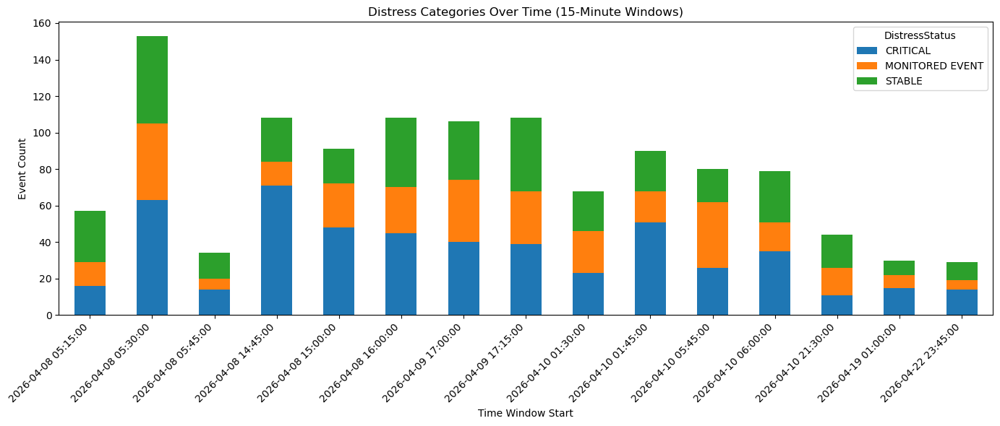
Visualizations

Figure 1: Distribution of distress categories (Critical, Monitored Event, and Stable) recorded in 15-minute intervals between April 8 and April 22, 2026.
We see clear spikes in activity across time, and during those spikes a large share of events fall into the Critical and Monitored categories. This suggests that increases in volume are often tied to more serious developments, not just noise. In practice, these spikes can act as early warning signs, helping flag moments where situations may be escalating in real time.
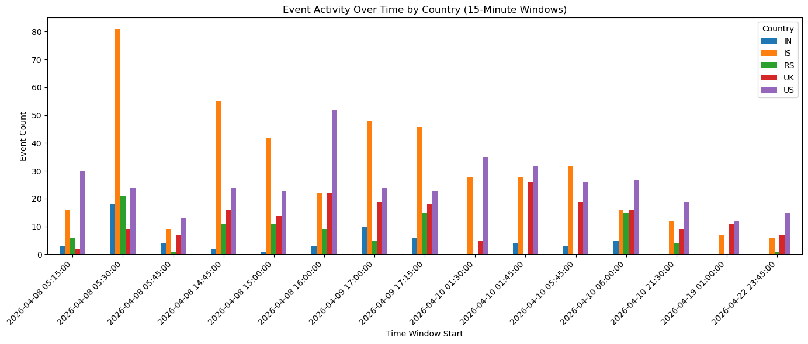

Figure 2: Event activity frequency by country (IN, IS, RS, UK, US) across 15-minute time windows from April 8 to April 22, 2026.
Event volume changes noticeably by country, with some showing steady activity and others experiencing sharp jumps. This reflects how conflict dynamics vary by region rather than following a single global pattern. Monitoring activity at the country level makes it easier to spot where attention is needed at a given moment.
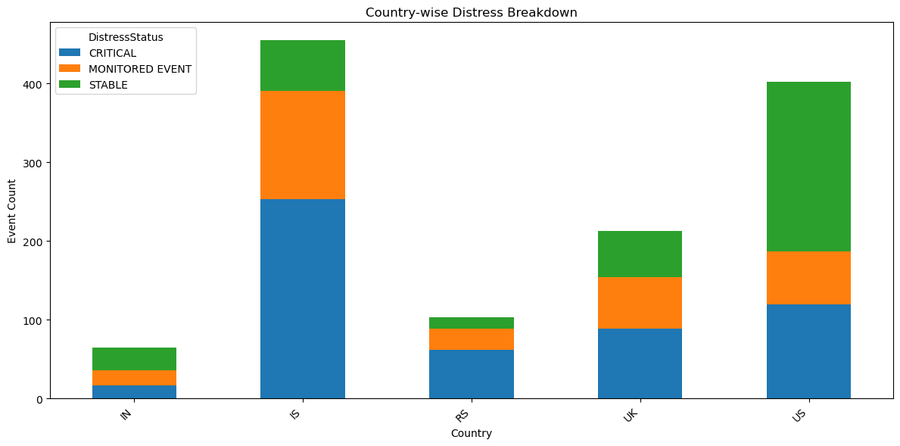

Figure 3: Total event counts by country, segmented by distress status (Critical, Monitored Event, and Stable).
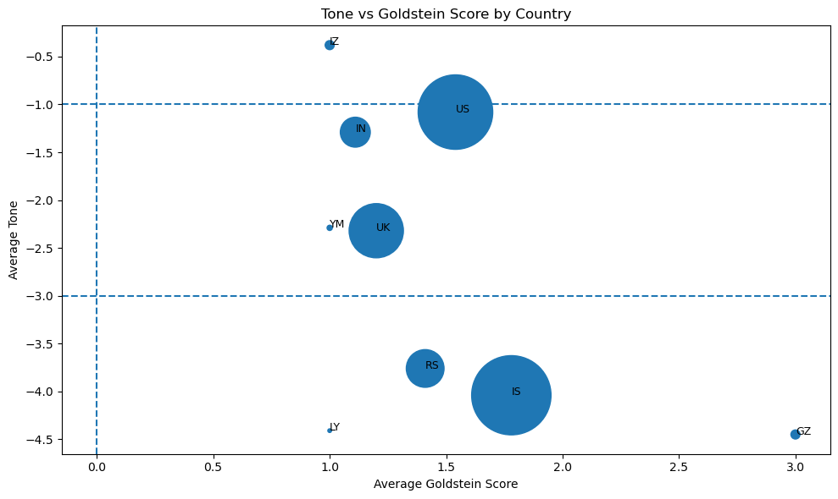
Countries differ not just in how many events they have, but in how severe those events are. Some have a higher share of Critical events, while others are mostly stable. This shows that volume alone doesn’t tell the full story. Focusing on severity helps prioritize which regions may require more immediate attention.

Figure 4: Bubble chart representing the relationship between Average Tone and Average Goldstein Score by country, with bubble size indicating event volume.
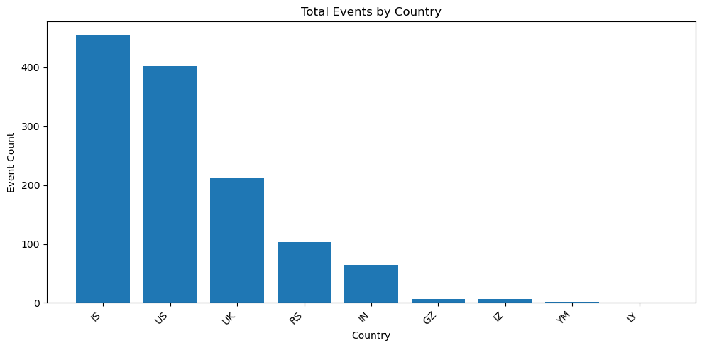
Countries with more negative tone generally align with more negative Goldstein scores, which supports the idea that sentiment reflects underlying conflict intensity. This gives confidence that the distress signal is capturing something real, not just arbitrary thresholds.

Figure 5: Total aggregate event counts by country, ranked in descending order.
Most events are concentrated in a few countries, while others have much lower volumes. This highlights where reporting is most active, but also reinforces that high volume doesn’t always mean high risk. Combining this with distress levels gives a more complete picture of where situations are actually critical.

Key Insights

Signal Validation and Noise Reduction
The results of this analysis confirm that high-frequency news data, when processed through a tiered distress classification framework, can yield a reliable leading indicator of conflict dynamics. A central finding is that event volume is an insufficient proxy for systemic risk. As demonstrated by the contrast between the United States and Israel (Figure 3), a high frequency of reporting often reflects media density rather than active escalation. By shifting the analytical focus from raw counts to event severity, the pipeline successfully isolates operational distress from media noise.
The consistency observed between temporal spikes and distress classifications suggests that the system is capturing meaningful geopolitical patterns rather than random fluctuations. Further, the data reveals that conflict escalation is non-linear, occurring in rapid, high-intensity bursts rather than steady trends. This temporal volatility reinforces the core premise of the project: that periodic, weekly reporting is structurally incapable of capturing the burst nature of modern crises. The validation of this signal suggests that sentiment-derived intensity, while not a substitute for ground truth, serves as a reasonable proxy for identifying escalation in its earliest stages.

Geopolitical Dynamics and De-escalation Patterns
The reporting period was defined by a significant global event between April 8 and April 10, 2026, which triggered activity spikes across all monitored countries (Figure 2). This synchronicity suggests that international media cycles are increasingly interconnected in which a singular headline can resonate across borders to create a temporary state of global distress. However, the subsequent decline in Critical event counts toward April 22 appears to indicate a de-escalation phase. During this window, initial critical shocks transitioned into Monitored and Stable categories (Figure 1), reflecting a shift from crisis to sustained diplomatic or administrative observation.
A deeper analysis of the relationship between Average Tone and the Goldstein Scale (Figure 4) identifies a High-Stakes Negative quadrant currently occupied by IS and RS. Despite the intensely hostile tone of the coverage, the moderate Goldstein scores indicate that these interactions, while friction-filled, have not yet triggered a total systemic collapse. This divergence between sentiment and structural impact provides a critical nuance for decision-makers: it allows them to identify regions that are experiencing intense rhetorical or diplomatic heat but have not yet crossed the threshold into kinetic or terminal instability. These localized, country-level insights demonstrate that a one-size-fits-all approach to global monitoring is inadequate as the conflict varies fundamentally by region.

Discussion and Implications

Closing the Temporal Gap: The Utility of High-Frequency Signals
The primary contribution of this system is the reduction of the latency between active events and analytical visibility. By transforming a 15-minute raw data stream into a continuous conflict signal, the pipeline fundamentally challenges the utility of traditional weekly or biweekly situation reports. In high-volatility environments where humanitarian aid deployment must be decided within hours, a perfect report that arrives late is operationally inferior to an imperfect signal that arrives in near-real-time. This project establishes that high-frequency monitoring provides a critical advantage, allowing organizations to transition from a reactive posture to one of proactive situational awareness.

Operational Constraints and the Proxy Nature of Tone
Despite its utility, the sentiment-derived distress signal must be interpreted within the context of the media. Because the system is anchored in the emotional tone of news coverage, it is inherently sensitive to media attention cycles and political relevance rather than purely physical escalation. This creates a visibility bias, where regions with a high density of international reporting may exhibit inflated distress signals compared to media-sparse areas experiencing similar levels of kinetic conflict. Furthermore, the issue of duplicate reporting – where a single event is captured across hundreds of sources – can inflate event volumes, creating a perception of widespread activity that may actually represent a localized incident with high media visibility.

Redefining Escalation in a Multi-Dimensional Framework
The analysis confirms that escalation is a multi-dimensional phenomenon that cannot be fully captured by a single metric. While tone serves as an effective proxy for immediate psychological and social distress, it does not always correlate with the structural impact of events as measured by the Goldstein Scale. The divergence observed between these two metrics highlights a key operational reality: a situation may be rhetorically hostile without being structurally terminal.
For the distress signal to evolve into a comprehensive early-warning system, it must move toward a multi-signal, combined flag. A more robust model would balance tone with event-type classification (e.g., distinguishing between a protest and a military strike) and geographic spread. Ultimately, the system in its current form should be viewed as a triage mechanism rather than a definitive ground truth. It identifies the "where" and "when" of change, serving as a high-fidelity trigger for deeper, human-led qualitative investigation, thereby ensuring that limited analytical resources are directed toward the areas of greatest systemic distress.

Limitations
While the GDELT ecosystem provides a high-frequency window into global events, the resulting distress signal must be interpreted within the context of specific structural constraints. A primary consideration is a reporting bias, where the uneven distribution of global media creates a disproportionate volume of data in high visibility Western regions. In these areas, the sheer frequency of routine news can create a false baseline of stability, whereas in media-sparse regions (often those in the greatest humanitarian need) only the most severe events reach the threshold of international reporting. This disparity necessitates that the signal be used as a relative measure of change within a country, rather than a direct comparison of absolute intensity between different nations.
Furthermore, the pipeline must contend with the issue of semantic duplication and information redundancy. Because a single kinetic event may be covered by hundreds of disparate news outlets, raw event counts are often inflated, creating a perception of widespread activity that may actually represent a singular, highly visible incident. While a tiered classification system prevents this by focusing on sentiment rather than volume, the signal remains a proxy for media concern rather than a definitive ground truth. Finally, it is important to note that while a negative sentiment spike identifies that a situation is deteriorating, it does not specify the nature of the required intervention.

Future Work and Scaleability
The current iteration of this pipeline establishes a foundation for high-frequency monitoring, yet several avenues remain to transition the system from a descriptive tool to a predictive intelligence framework. A primary objective for future development is the implementation of a multi-dimensional model. By moving beyond sentiment-based proxies to incorporate CAMEO escalation chains, the system could identify specific tactical sequences, such as diplomatic expulsions or economic sanctions, that historically precede conflict. Integrating actor-type distributions and sub-national geographic codes would further refine this granularity, allowing for a more precise understanding of the mechanics of escalation beyond generalized media tone.
Furthermore, the utility of the distress signal can be significantly bolstered through external validation and benchmark calibration. By cross-referencing GDELT-derived escalation flags with authoritative datasets such as ACLED (Armed Conflict Location & Event Data Project) and OCHA bulletins, the system’s tone thresholds can be calibrated for greater empirical accuracy. This validation process would be complemented by retrospective stress-testing, applying the pipeline to historical conflict data to evaluate its ability to detect known operational shifts in real time.
Finally, the project aims to develop a CAMEO-Based decision framework. This layer would analyze sequences of event codes to bridge the gap between detection and deployment, identifying pre-crisis indicators that trigger specific humanitarian actions. For example, detecting a sequence where a "Threaten" code (CAMEO 130) is followed by "Coerce" (CAMEO 170) could serve as a trigger for the pre-positioning of aid resources. By transforming raw event sequences into actionable decision triggers, the system will move closer to providing the comprehensive, anticipatory intelligence required for modern humanitarian response.

Conclusion
The primary challenge of GDELT is not a lack of information, but an overwhelming surplus of it. While the platform captures global events every 15 minutes, the resulting volume of data generates a level of noise that renders manual review infeasible. This project moves beyond mere data collection by establishing a systematic framework for signal extraction.
By implementing a three-tier distress classification centered on the emotional valence of global reporting, we have successfully compressed millions of raw records into a high-fidelity, country-level index of conflict intensity. This transformation allows for the identification of systemic shocks in near-real-time, a capability that standard reporting cycles cannot match.
The strategic implication is significant: organizations tethered to traditional weekly situation reports are operating with a structural information disadvantage. We have demonstrated that the data required to close this gap is already accessible; the barrier was the lack of a reliable mechanism to filter relevance from noise. With this capability validated and ready to scale, the next phase of development will focus on integrating deeper qualitative context to further refine the intelligence provided to stakeholders.

References
GDELT Project. (2026). The GDELT Project. https://www.gdeltproject.org/
Leetaru, K., & Schrodt, P. A. (2013). GDELT: Global Data on Events, Language, and Tone, 1979-2012. ISA Annual Convention.
Schrodt, P. A. (2012). CAMEO: Conflict and Mediation Event Observations Event and Actor Codebook. Pennsylvania State University.
Apache Spark. (2024). Structured Streaming Programming Guide. https://spark.apache.org/docs/latest/structured-streaming-programming-guide.html
Armed Conflict Location & Event Data Project (ACLED). https://acleddata.com/
UN Office for the Coordination of Humanitarian Affairs (OCHA). https://www.unocha.org
Google. (2026). Gemini 3 Flash [Large language model]. https://gemini.google.com/

Acknowledgements
The authors utilized Gemini (Google) for structural refinement, linguistic polishing, and the synthesis of technical definitions within this report. All data analysis, AWS pipeline architecture, and final interpretation of GDELT signals were performed by the human authors.

Notes
Fidelis, please review the notes and add your comments. I do not want to start writing a report that is not reflecting your changes to code.

Index proposal:
- Intro– GDELT data could be used for humanitarian reasons to provide supplies and help…etc
- GDELT data presents the opportunity to follow in real time the escalation of situations per country.
  - brief problem statement early on (GDELT data is high-volume and noisy, so we need a way to extract meaningful signals).
  - Creation of distress signal: definition, details, why is this important
  - ADD THE GRAPHS AND USAGE OF THEM. n the graphs section, structure each visualization with what we observe → interpretation → implication so it clearly shows value, not just results.
- Key Insights
- Next steps
  - Addition of Actor, CAMEO code to detail the escalation by type of incident.
  - More detail means better decisions on what is needed and where.
- Conclusion
GDELT is a fountain of information and we can only increase its usability for humanitarian aid. Business and markets are always looking for the latest information in real time and the addition of more features could benefit not only the non profits but business as this is a globalized economy and critical situations can disrupt business around the world.

Time stamp: UTC? MT?
Countries in the file:
|Country|event_count|avg_tone|avg_goldstein|
+-------+-----------+--------+-------------+
|IS |455 |-4.04 |1.78 |
|US |402 |-1.08 |1.54 |
|UK |213 |-2.32 |1.2 |
|RS |103 |-3.76 |1.41 |
|IN |65 |-1.29 |1.11 |
|GZ |6 |-4.45 |3.0 |
|IZ |6 |-0.38 |1.0 |
|YM |2 |-2.29 |1.0 |
|LY |1 |-4.41 |1.0 |
+----

When did you added the new Countries?
For example:
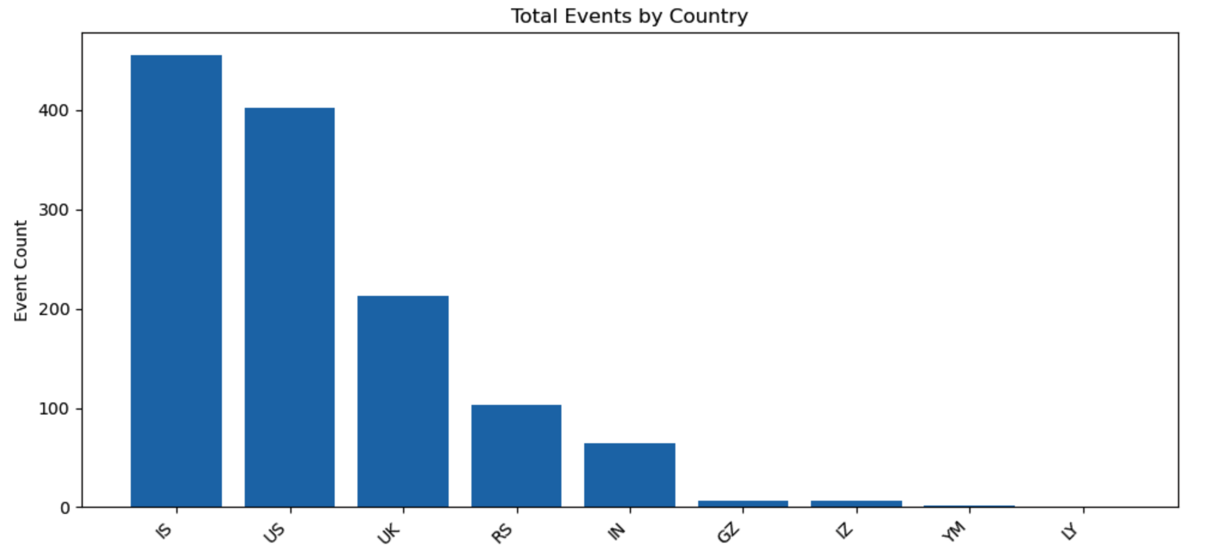
For this graph, what is the time line for this? Can I say that is the Top 5 countries from our report?
